Assisted Practice: 27 Name: Prajwal Diwakar

Random Timers-Constant, Gaussian, and Poisson Random Timers.

Constant Timer:

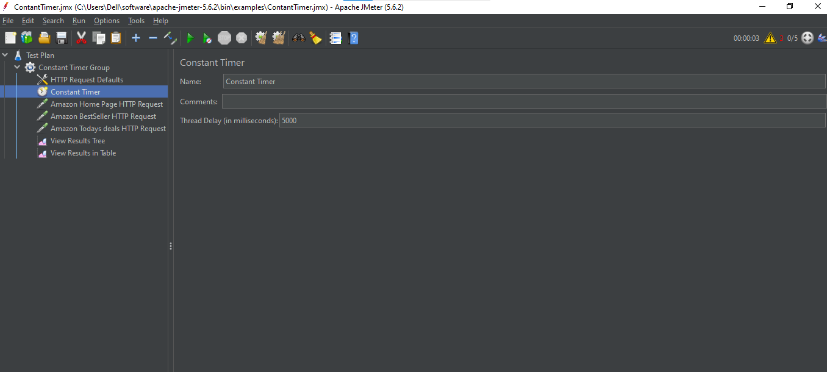

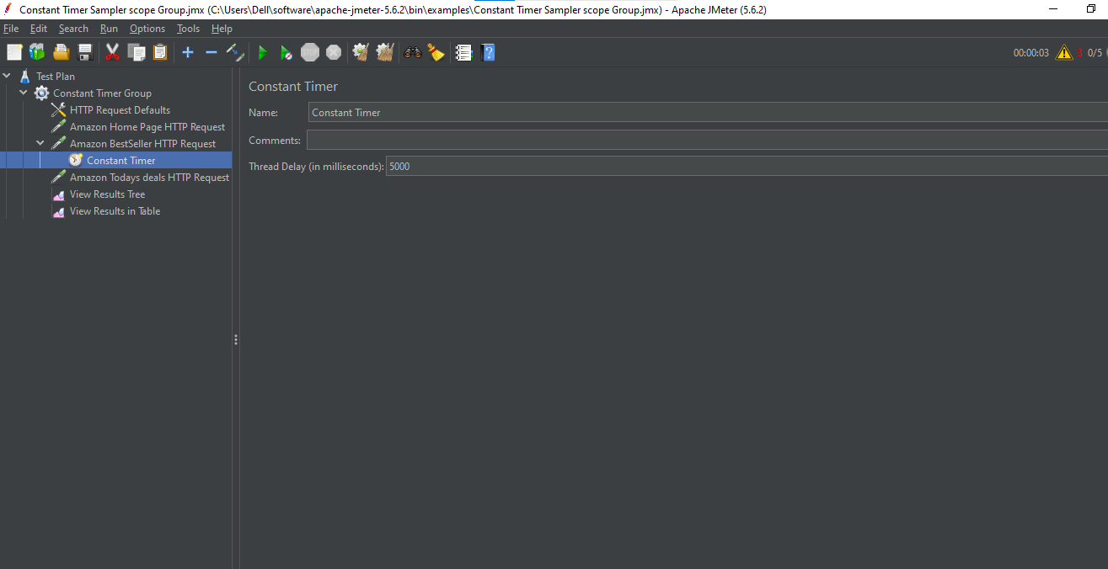

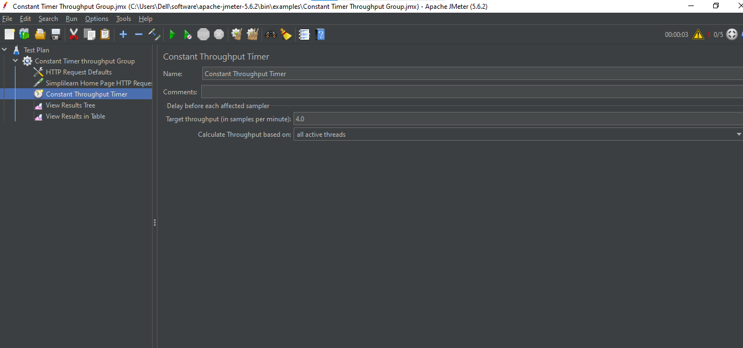

Gaussian Timer:

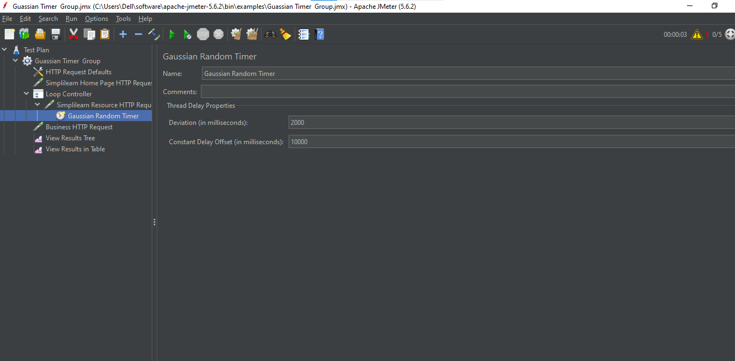

Poisson Random Timers:

